Tabla de contenido

Module 2: Auto-Regressive and Moving Average Model - Case Studies 2

2.4: Data Examples 2

2.4.1 IBM Stock Price: ARMA Modeling 2

2.4.2 IBM Stock Price: Forecasting 7

2.4.3 Energy Consumption: Exploratory Data Analysis 13

2.4.4 Energy Consumption: Forecasting 18

# Module 2: Auto-Regressive and Moving Average Model - Case Studies

## 2.4: Data Examples

### 2.4.1 IBM Stock Price: ARMA Modeling

In this lesson, I will illustrate ARIMA modeling and forecasting with a data example.

**IBM Stock Price Prediction**

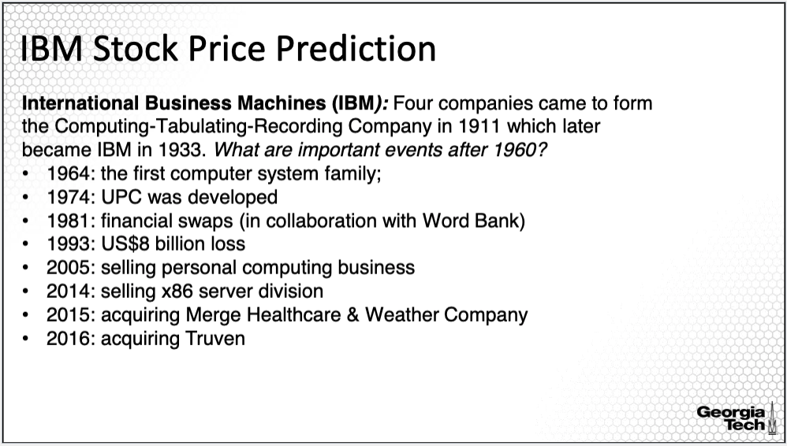

The data example is analyzing the stock price for a large company which has been around for many years. Specifically, we'll focus on IBM, standing for International Business Machines. The company was initiated in 1911 as the Computing-Tabulating-Recording Company, which was a merger of four companies. Later in 1933 it became IBM. Since the company has been around for more than 100 years, it has contributed to many innovations and has experienced many disruptive events as provided on the slide. For example, in 1993, it experienced the highest loss in its history to date, a loss of $8 billion and in 2005, it sold its personal computing business, since it was not sustainable.

**IBM Stock Price**

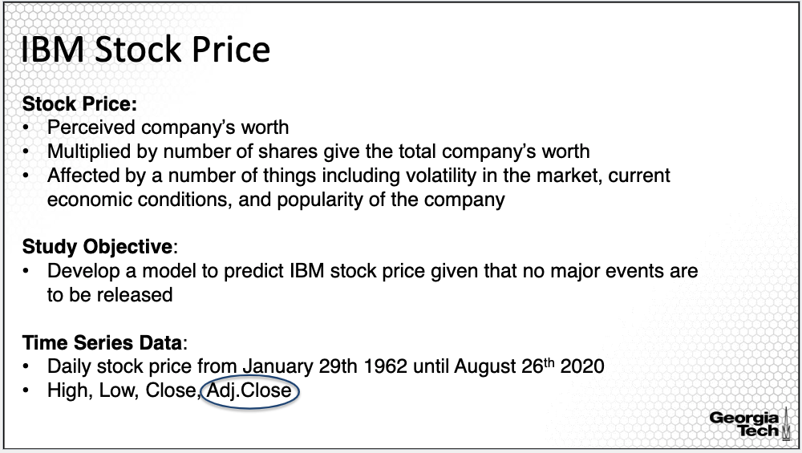

What is a stock price? In financial terms, it is viewed as the perceived company's worth since multiplied by number of shares gives the total company's worth. It is generally affected by the number of things including volatility in the market, current economic conditions, popularity of the company, and events as the ones I mentioned in the previous slide.

The analysis in this study is to develop a model to predict IBM's stock price given that no major events are to be released. The model presented in this lesson is general and applies to the stock price of other companies, although its performance will be different.

The data consists of daily stock price from January 29th 1962 until August 26th 2020. The daily stock price is available as open price, close price, and adjusted close high and low price.

We'll consider here adjusted close, which is the common price analyzed when daily stock price predictions are sought.

**Time Series Plots**

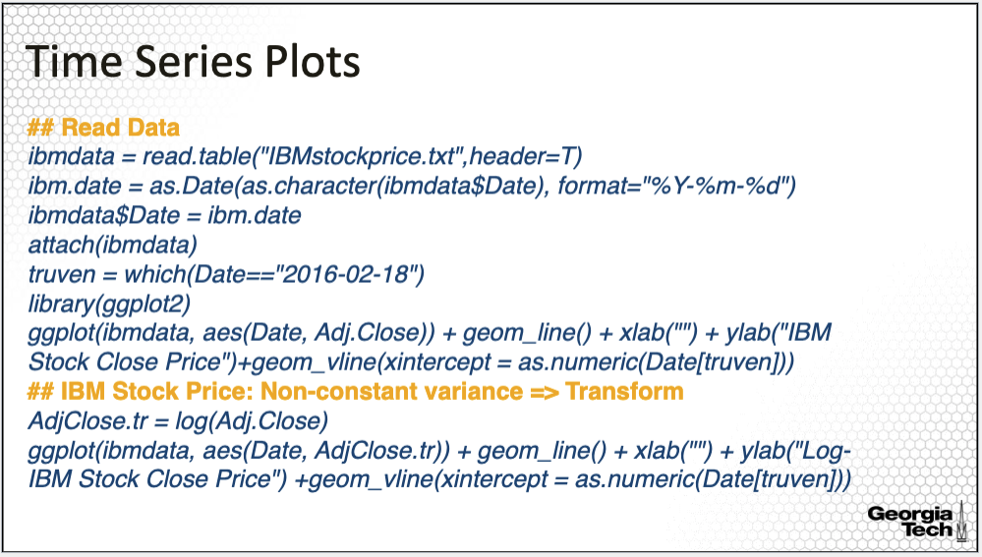

The input is the file *IBMstockprice.txt*, accompanying this example. I used the as.date() command in R to convert the date, providing the data into a date object in R. For this command, the input is the vector of dates converted into character with the specification on how the dates are recorded. Furthermore, I defined one of the events called Truven to be the date of acquisition of the Truven company in 2016. The other events are defined similarly.

I used the ggplot command with inputs, the date and the adjusted closed price, to plot the time series along with the vertical lines indicating the event acquisition of Truven in 2016, and also other events as provided in the plot. The vertical lines for all other events are added similarly as for Truven. I did not provide the entire R-code here. You can find the complete R code accompanying this lesson. Last, I also considered a transformation of the price, specifically, the log transformation.

The GG plot of the adjusted close price is on the top left; the time series plot also includes the vertical lines indicating when all the events mentioned in the previous slide happened. There are several characteristics to point out. The trend is overall monotone, increasing with fluctuations in the later decades. There is no clear seasonality that can be evaluated visually. However, we can note the heteroscedasticity or non-constant variance of the time series.

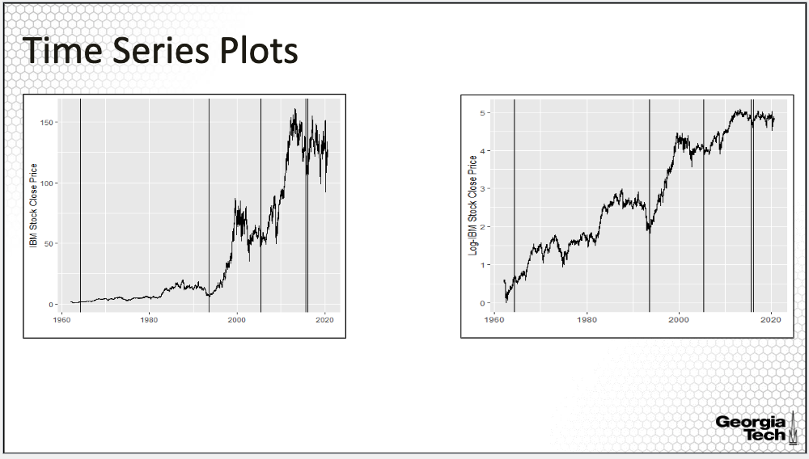

The variability in the stock price clearly shows a big change from being significantly smaller in the early years versus much larger in later years. We also note that the events did not clearly trigger significant changes at least as seen on this scale. For earlier events it is hard to distinguish any differences because of the difference in scale. The price is low with low volatility around 1995 with more distinguishable changes thereafter. In fact, in order to better distinguish patterns throughout the entire time period, it is a good idea to use a transformation that stabilizes the variance and amplifies local patterns such as the log transformation. Here (in the lower right plot) I used this transformation on the adjusted close price.

On the log scale, the patterns in the earlier years are much easier to distinguish. For example, we can see the increase in the stock price after the first family computer was launched in 1964. And we also see a significant drop in the price when the company had a very large loss in 1993. The merger and acquisition in 2015 and 2016 are followed by an increase in the stock price.

**Assessing Dependence & Stationarity**

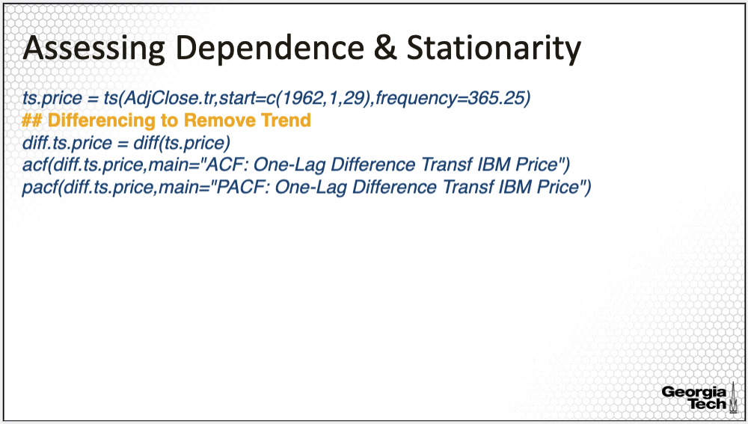

One way to account for the trend is to consider the difference process. Here I redefine the stock price as the time series with a frequency specifying daily data starting with January 29th, 1962. Then I use a difference command to take the difference, where the default in this command is the first order difference. I also plotted the ACF and PACF to see whether another difference of the data is needed and/or whether the resulting process is stationary.

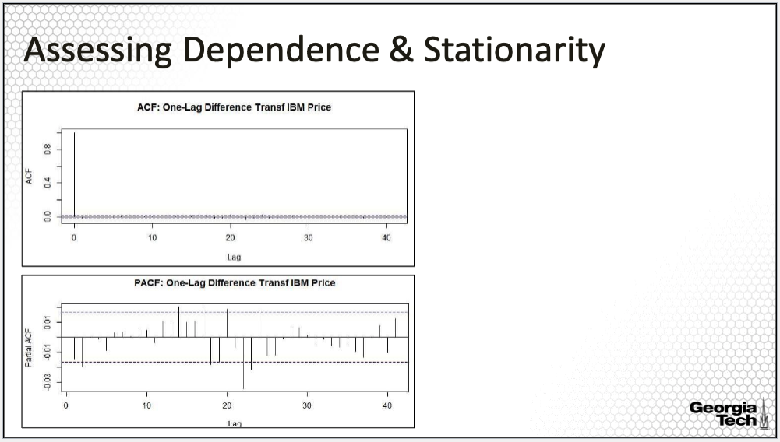

Here are the ACF and the PACF plots. The two plots look just like those for the white noise we simulated in a previous lesson. Do we still then, need to apply an ARMA model to model the difference process, or is it enough to take the difference since the difference process seems to look like white noise? We'll address this question in this lesson and the next lesson.

**ARIMA Modeling**

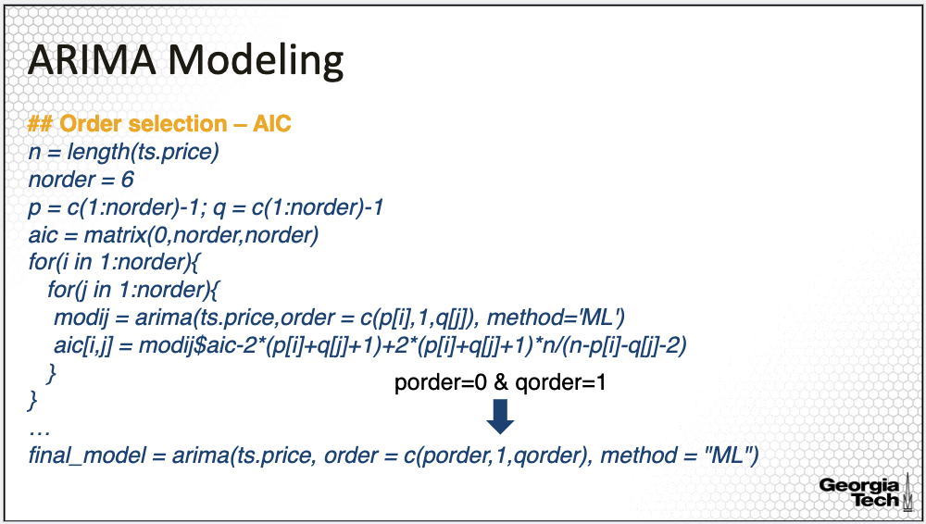

Next, I applied the ARIMA modelling. I used ARIMA to take into account the trend through differencing. I assume only one order difference and thus set the difference order equal to one. Here I only selected the orders of the AR and MA polynomials using the AICc criterion. For this we need to fit the ARMA model for all combinations of AR and MA orders up to the maximum order for both polynomials. Here I set the maximum order to be five, and consider orders from zero to five for both the AR and MA components. I loop over all combinations of the orders and fit the ARMA model for all those combinations and save the AICC values in a matrix for all the combinations. Note that the R implementation does not provide the AICC value but the AIC without the modification.

The selected orders are p equal to 0 and q equal to 1. Last, we fit the model for the selected orders called here, the final model.

**ARIMA Modeling: Residual Analysis**

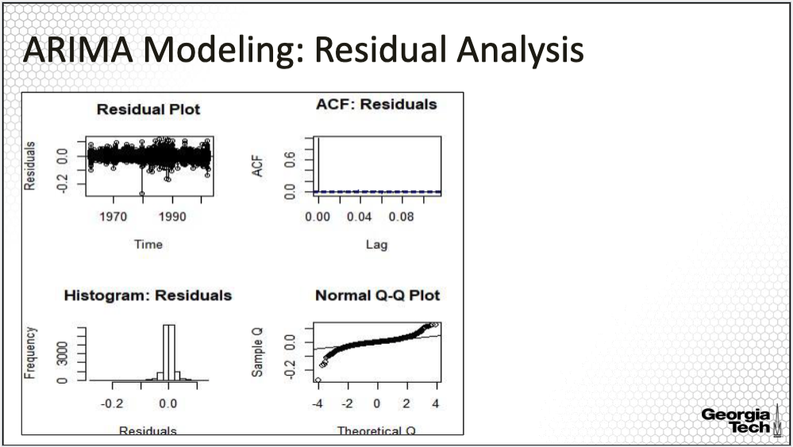

Here are the residual plots for the fitted ARMA Model. The R-code for obtaining this plot is provided in the complete R-code for this data example available with this lesson. The residual plot does not show to have a pattern. The variance of the residuals is also constant. The ACF plot has only the first lag equal to one, where all other values for the sample ACF are small within the confidence band. The same for the sample PACF, the values are all within the confidence band. The Q-Q normal plot shows both a left and a right tail, an indication that the residuals may have more of a T distribution than a normal distribution, although otherwise quite symmetric.

**Testing for Uncorrelated Residuals**

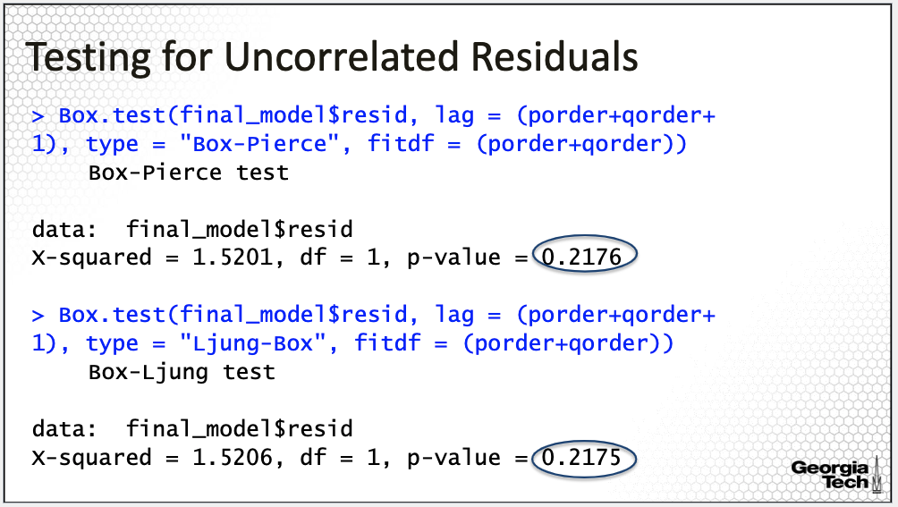

Last, we also apply the hypothesis testing procedures for independence or serial correlation using the Box-Pierce and Ljung-Box test. The R output of these implementation is here. In this implementation, we need to input the lag for the test statistic and fitdf for the distribution under the null hypothesis.

Here I used the lag to be equal to the sum of the AR and MA order plus 1 and the degree of freedom of the fitted model to be the sum of the two orders. It is common practice to use a minimum lag for the test to be as provided by the sum of the orders plus 1. The R output provides the test values along with the p-value of the test. Note that the null hypothesis in this test is that the time series process (here it is the residual process) consists of uncorrelated variables. Thus, this is one case when we want large P values so that we do not reject the null hypothesis.

The P values for both tests are large, indicating that it is plausible for the residuals to be uncorrelated.

**Summary:**

In summary, in this lesson I illustrated the ARIMA model fitting with the data example of forecasting the IBM stock price.

### 2.4.2 IBM Stock Price: Forecasting

In this lesson, I will focus on forecasting of the ARMA model for the IBM stock price.

**IBM Stock Price**

I'll remind you that the analysis in this study is to develop a model to predict IBM's stock price.

We'll only consider here adjusted close price, which is the common price analyzed when daily stock price predictions are sought.

**ARIMA Forecasting**

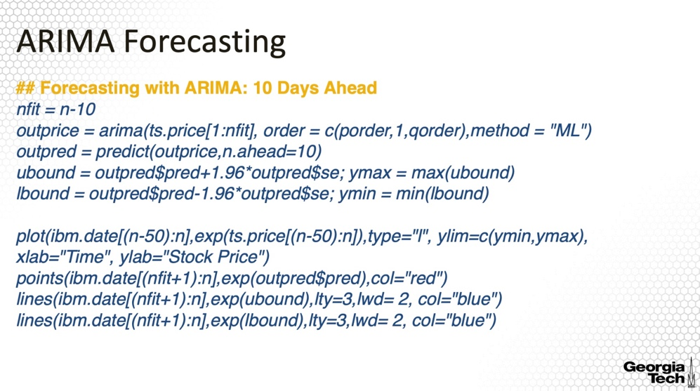

We'll first implement and evaluate a 10-days ahead prediction for the log-transformed stock price. For this, I set apart the last 10 days of the time series, fit the model based on a time series discarding the last 10 days, and then predict the last 10 days to compare with the observed values of the time series for these 10 days.

The predict command in R takes as an input the ARMA object along with the number of lags for the prediction. The prediction provides the predicted time series values, along with point-wise confidence intervals for the prediction. Here I also plotted the time series data along with predicted values and the confidence band.

I did not plot the entire history of the time series, but only the last 50 days of the time series. I overlayed the predicted values in red along with the confidence band in blue. Note that when I plotted the data along with the predictions, I transformed them back using the exponential function since here we predicted the log of the stock price, and not the stock price itself. Thus, for evaluating the predictions of the stock price we need to transform back with the inverse of the log function, the exponential. The same exponential transformation is applied to the lower and the upper bounds.

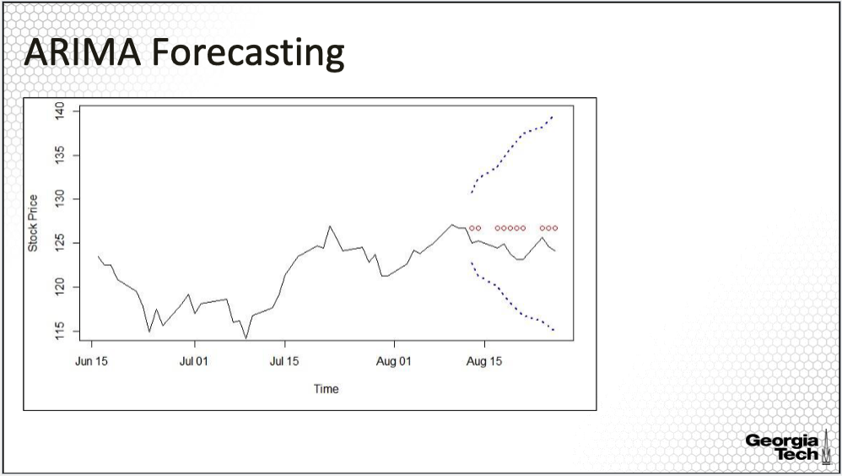

The corresponding plot is here. The black line is the observed time series. The red points are the predicted values along with the confidence bands in blue. All the observed values are within the confidence band. The predicted values are somewhat closer to observed values, except that they do not capture some of the variations in the stock price. The confidence band is quite wide, widening as the lag increases also, indicating there is large volatility or uncertainty, in the prediction.

**Prediction Accuracy**

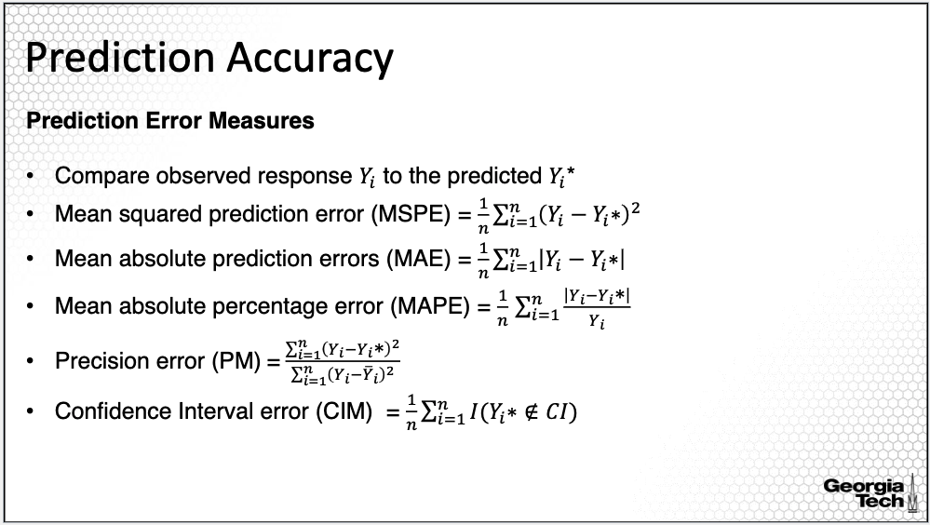

But how good are these predictions? We can compare the predictions derived from applying the predict() command based on the training data to the observed responses in the test data. In the real world, we do not have the observed responses at that time of making the predictions, and thus we cannot evaluate the prediction accuracy of a model. But here, we first pretend we do not have the observed future time series values and predict based on the training data. Generally, the question “how good is the prediction?” comprises two separate aspects. Firstly, measuring predictive accuracy per se. Secondly, we compare various forecasting models. The most common reported measures of predicting accuracy are:

* Mean squared prediction error abbreviated MSPE and computed as the mean of the square differences between predicted and observed;
* Mean absolute prediction errors abbreviated MAE and computed as the mean of the absolute values of the differences between predicted and observed;
* Mean absolute percentage error abbreviated MAPE and computed as the mean of the absolute values of the differences scaled by the observed responses;
* Precision error abbreviated PM and computed as the ratio between MSPE and the sum of square differences between the response and the mean of the responses;
* Confidence Interval Measure abbreviated CIM computed as the number of predictions falling outside of the prediction intervals divided by the number of predictions made.

**Prediction Error Measure Insights**

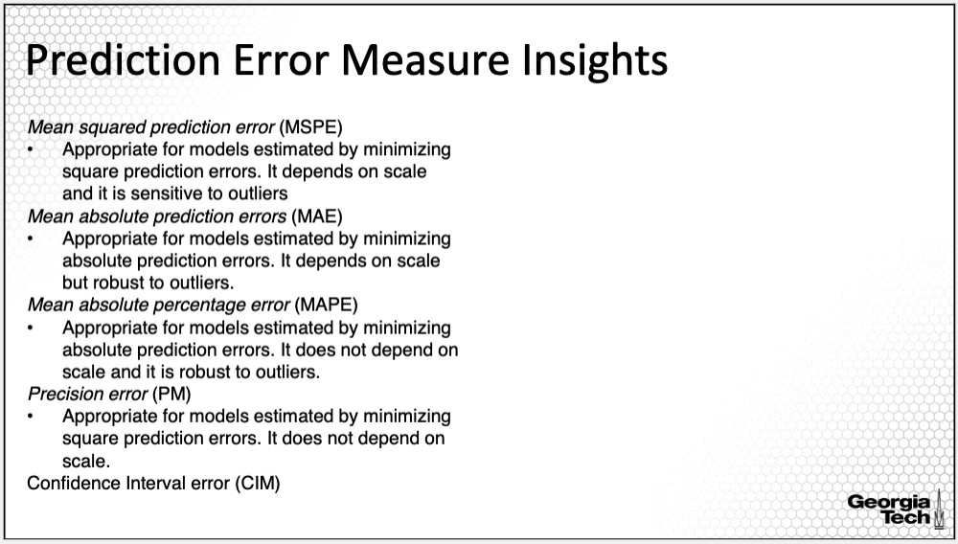

MSPE is appropriate for evaluating prediction accuracy for models estimated by minimizing square prediction errors, but it depends on the scale of the time series data, and thus is sensitive to outliers.

MAE is appropriate for evaluating prediction accuracy for models estimated by minimizing absolute prediction errors; similar to MSPE, it depends on scale, but it is robust to outliers.

MAPE is appropriate to evaluate prediction accuracy for models estimated by minimizing absolute prediction errors, but unlike MAE, it does not depend on scale. It is also robust to outliers.

Last, the precision error is appropriate for evaluating prediction accuracy for models estimated by minimizing square prediction errors. It also does not depend on scale. The precision measure is reminiscent of the regression R squared. It can be interpreted as a proportion of the variability in the prediction versus the variability in the new data.

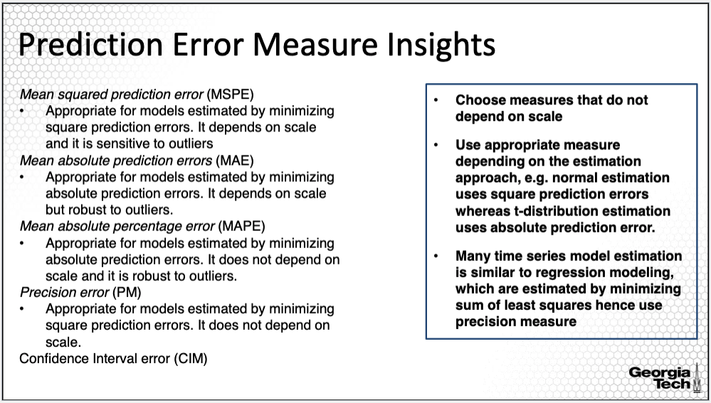

Generally, we prefer measures that are not scale dependent since they are comparable across models. Moreover, you will also need to understand what estimation approach was used in order to select the appropriate measures. For example, many time series models are using similar estimation approaches to standard regression modeling, which are estimated by minimizing sum of least squares. Hence for such models, it is appropriate use the precision measure.

Using MLE assuming normal distribution implies a square prediction error hence again you should use the precision measure. However, if for example, you use MLE assuming t-distribution for the time series data, then MAPE is appropriate. Thus, while MAPE is one of the most used prediction error measure, it is not appropriate to be used to evaluate prediction accuracy for most time series models.

**Prediction Accuracy: 10 Days Ahead**

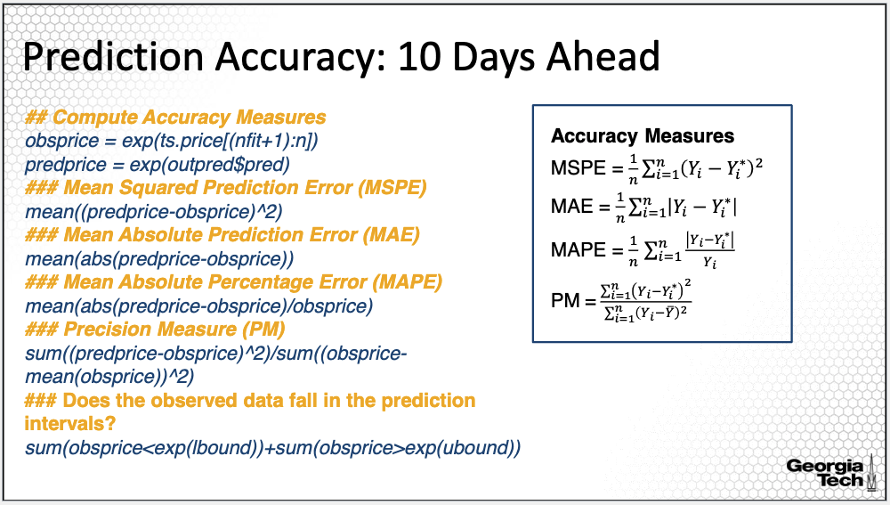

Here I am comparing the 10-day ahead predictions with the observed time series values. The R implementation using the accuracy measures I introduced in the previous slides are on this slide. Note that I took the exponential of the observed and predicted values since the data and the predictions are on the log-scale. The implementation of the measures follows the formula provided for the five measures also provided on the slide.

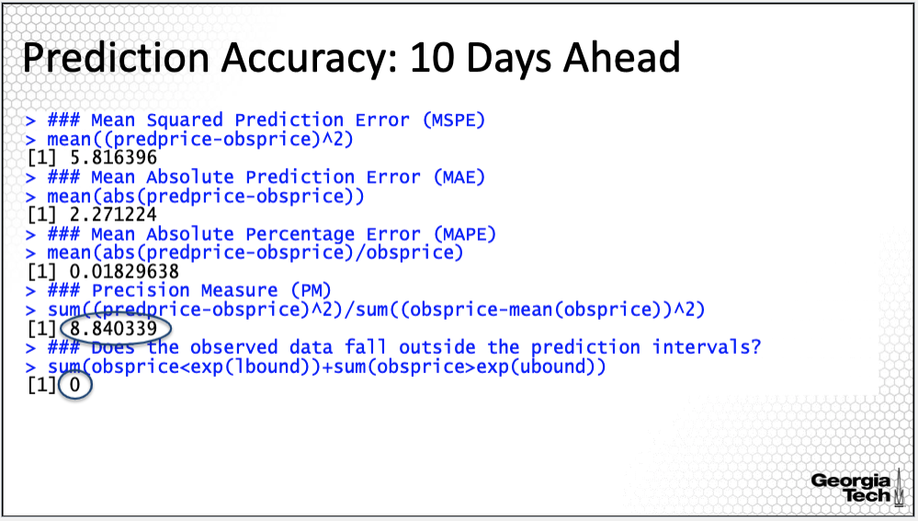

The precision measure is 8.84, which measures that the proportion between the variability in the prediction and the variability in the new data. The closer this value is to zero, the better the prediction is. However, the prediction measure is quite large indicating poor performance in predicting the 10 days.

Last, I also note that all observed responses fall within the prediction intervals. However, as I pointed out before, the prediction bands are quite large, indicating significant uncertainty in the predictions.

**ARIMA Forecasting: 1 rolling day vs 10 day ahead**

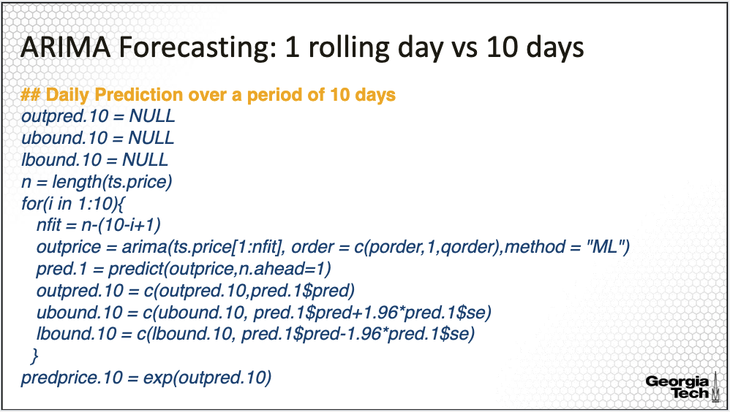

Let's also consider prediction of the 10 days, but this time on a rolling basis. That is for each day, we fit the model with the entire time series up to that day and predict only one day ahead. Apply this for each of the 10 days. To do this I used a loop command for i from 1 to 10 where each i corresponds to one different day. We then save not only the prediction but also the prediction intervals. Last, I plug in the predictions based on this approach along with the observations of the time series. The complete R code is not provided here in this slide, but it's available with this lecture.

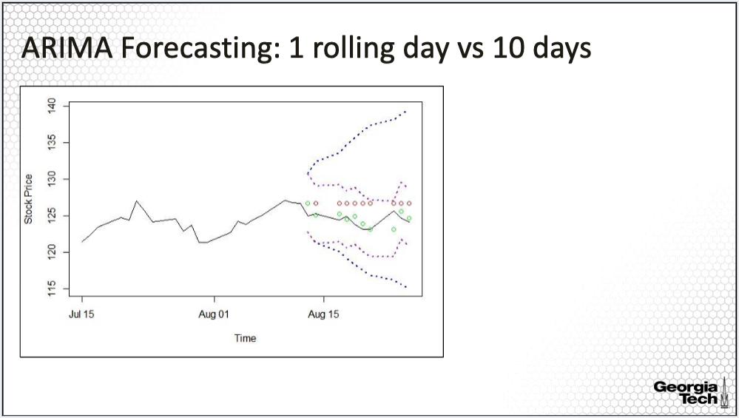

The plot here compares the predictions from this approach, where the predictions for each of the 10 days were made on a rolling basis, to the prediction made 10 days ahead. As expected, the predictions using the one day ahead, shown in green, are much closer to the observed time series values than the predictions from the 10 days ahead approach, shown in red. Moreover, the confidence bands from the rolling basis predictions shown in purple are much tighter than for the 10 day ahead predictions. This is again expected since there is less uncertainty from one day to another, as compared from one day and looking 10 days ahead.

**Prediction Accuracy: 1-Day Ahead**

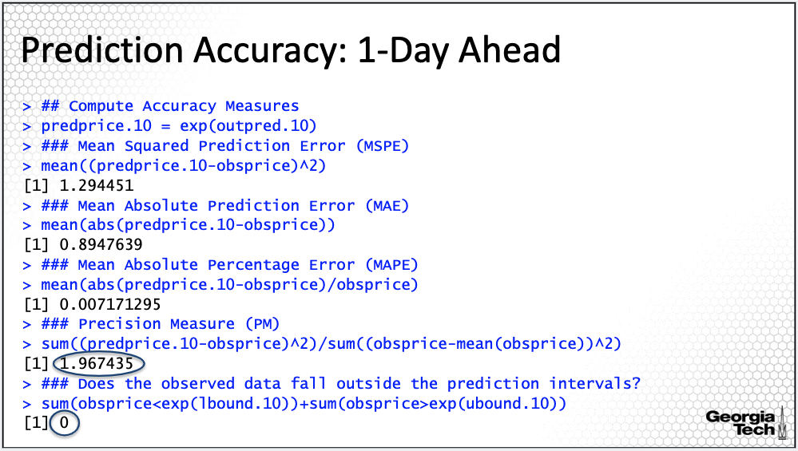

Similar to the previous approach, we can also evaluate the accuracy of the prediction using accuracy measures. The R code is the same as before, except that it is now applied to the predictions based on the one day ahead rolling basis approach.

The R output is here. Now the precision measure reduced significantly to 1.49 versus 8.84 for the 10-day ahead predictions.

While the prediction bands are tight for the 1-day rolling predictions, the observed values are all falling within the prediction bands. The predictions using the one day ahead approach on a rolling basis are preferable, since the predictions are significantly better, however, we cannot always use such an approach since there are situations when we want to predict 10 days ahead in the future rather than one day ahead. Generally, different models may be used for different lags ahead prediction.

**Summary:**

This lesson illustrated forecasting using the ARIMA model of the stock price of one large company, IBM. A similar approach can be applied to the stock price of other companies.

### 2.4.3 Energy Consumption: Exploratory Data Analysis

*This lesson introduces another data example, this time related to the energy industry, specifically, analyzing the time series of monthly electricity consumption. Here I will perform an exploratory analysis and in the next lesson I will continue with forecasting electricity consumption.*

**Electricity Consumption**

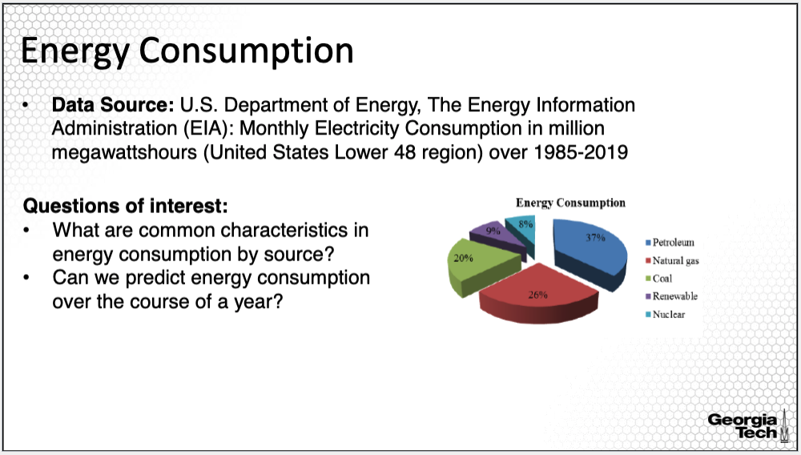

In this data example, we will focus on monthly electricity consumption data, as it can be used in inferring characteristic on U.S. overall energy consumption. The data were acquired from the U.S. Department of Energy, The Energy Information Administration. The data are available starting 1985 until 2019. The data are available monthly and daily.

In this example, we will analyze the monthly data because the objective here is to perform predictions of electricity consumptions over the upcoming year assuming similar consumption behaviors as in the past years. Of course, this will not be the case of 2020 due to the developments following the covid19 crisis. For this reason, we will evaluate the electricity consumption only until 2019. In this lesson, we will primarily analyze the characteristics of the time series of electricity consumption, for example, evaluate the trend, seasonality and more generally the serial correlation.

**Time Series Plots**

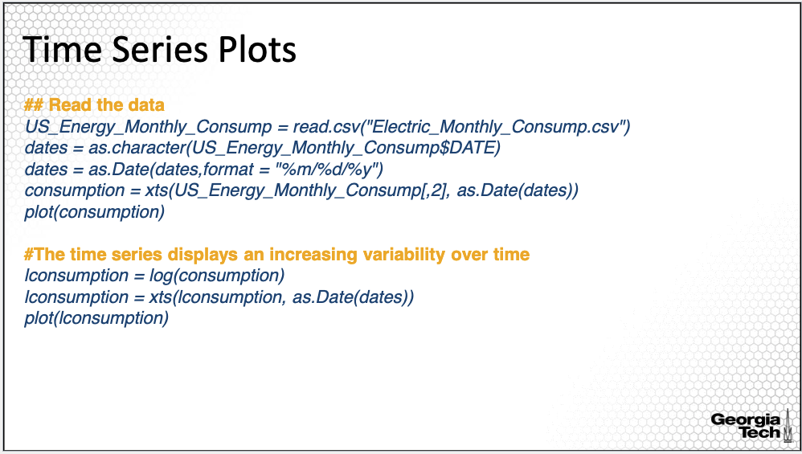

Let’s begin again by plotting the time series. Please note that over the course of the R data analysis lessons, I have and will be using various approaches to converting data into time series and to plotting it. When performing your own data analysis, you will decide which one you like best! Here the command to convert the data into a time series is the xts() command. Here I also transformed the time series using the log-transformation as I will motivate in the next slides.

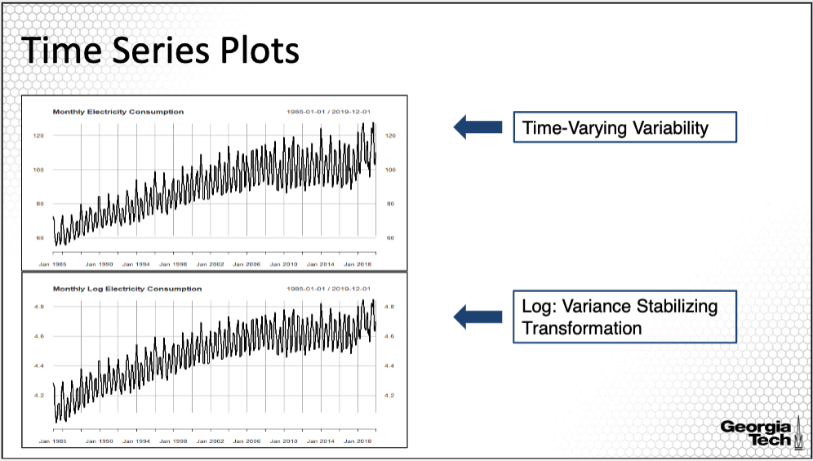

The time series plots are on this slide. The top figure is for the original time series and the bottom figure is for the log-transformed time series. Some observations from these two plots are as follows.

The variance of the original time series depends on time. There is also a clear non-linear trend as well as there is a clear seasonality or cyclical pattern, indicating that the time series is non-stationary.

The log transformation of the time series is needed to stabilize the time-varying variability before doing trend and seasonality analysis.

**Why transforming?**

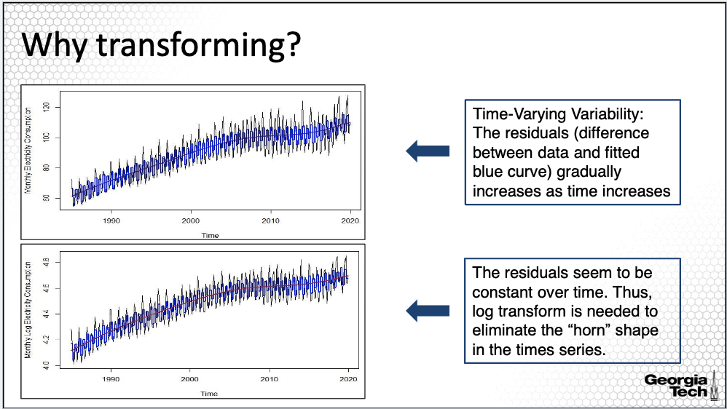

Here I am motivating why we need to transform the time series before evaluating the trend and seasonality. Let’s skip ahead and fit a quarter seasonality along with the trend as shown in blue in the two time series plots.

When comparing the two plots, we can see that the differences between the original time series and the fitted seasonality and fitted trend gradually increase over time, with lower residuals for earlier times and larger residuals for more recent times. In contrast, for the transformed time series, we can see the variability in the residuals is relatively the same or constant over time. In the following analysis, we will perform the analysis on log transformed monthly electricity consumption.

**Trend Estimation**

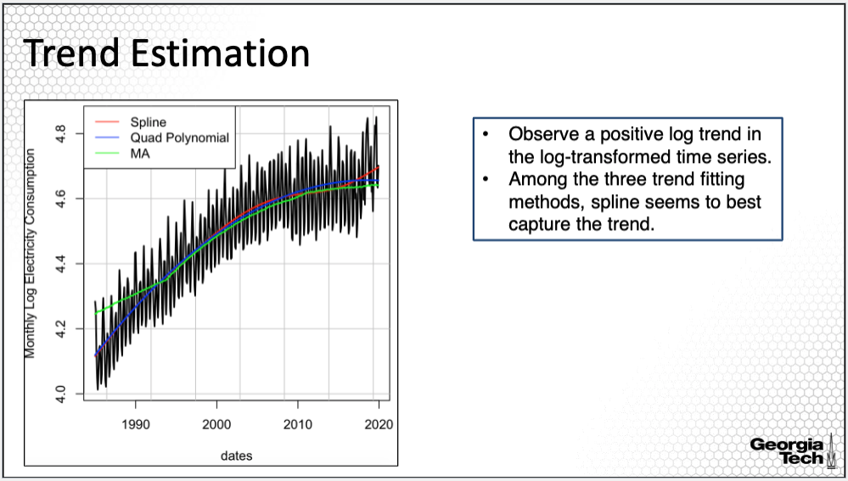

Generally, when removing trend or seasonality, we don't just delete information. As discussed in Module 1, we take that information apart in order to analyze separately each part of the behavior. Here are going back to analyzing one component, the trend. You can use your favorite method in Module 1 to capture the trend in the time series. Here we fit spline regression, parametric quadratic polynomial and moving average smoothing to the log transformed time series. Overall, we can observe a positive logarithmic trend in the log-transformed time series. Among the three trend fitting methods, spline seems to best capture the trend. The moving average fit seems to miss the fit at the beginning and at the end of the time period.

**Trend & Quarterly Seasonality**

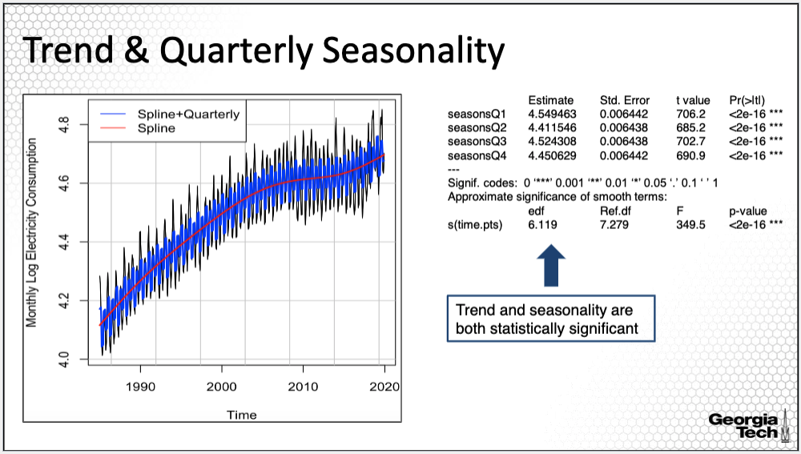

In addition to the trend fitting, we are quite certain that there is seasonality in the time series as well. Thus, lets capture trend and seasonality jointly. Here I used spline regression to fit the trend and quarterly factor to capture seasonality. The plot with the data along with the fitted trend and seasonality as well as the model output are on the slide. The fit looks good at least visually.

Based on the output, we find that the trend and seasonality are both statistically significant, however we can see that some of the seasonality has not been captured.

**Trend & Monthly Seasonality**

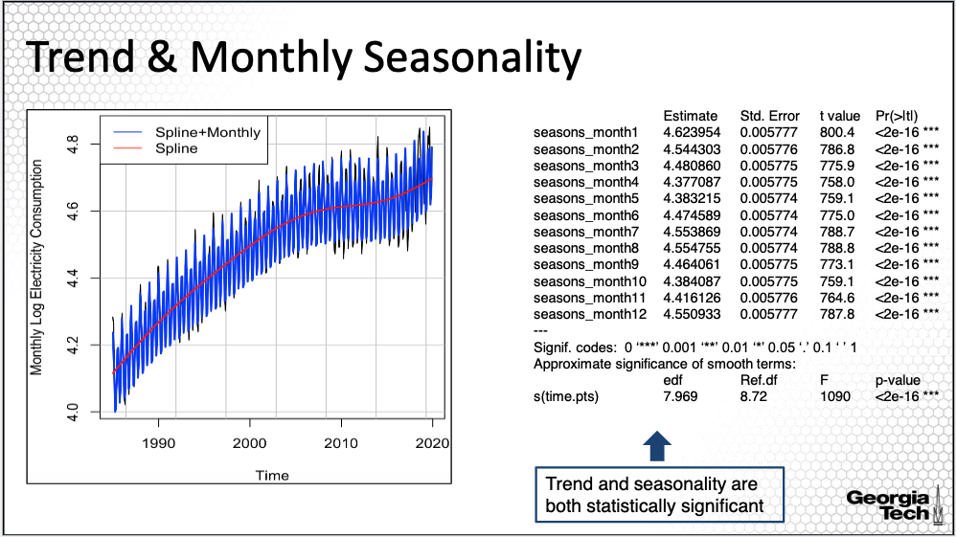

The previous slide shows that the trend and quarterly seasonality fit. However, it is possible a monthly seasonality would fit better. Let’s now try to use monthly factors instead of quarterly factors to capture seasonality. This slide again presents the plot with the data along with the fitted trend and seasonality as well as the model output. At least visually, the monthly seasonality captures the ups and downs much better than quarterly seasonality.

Moreover, the monthly factors are all statistically significant, demonstrating that monthly factors produce a better fit for seasonality.

**Trend & Seasonality: Residual Analysis**

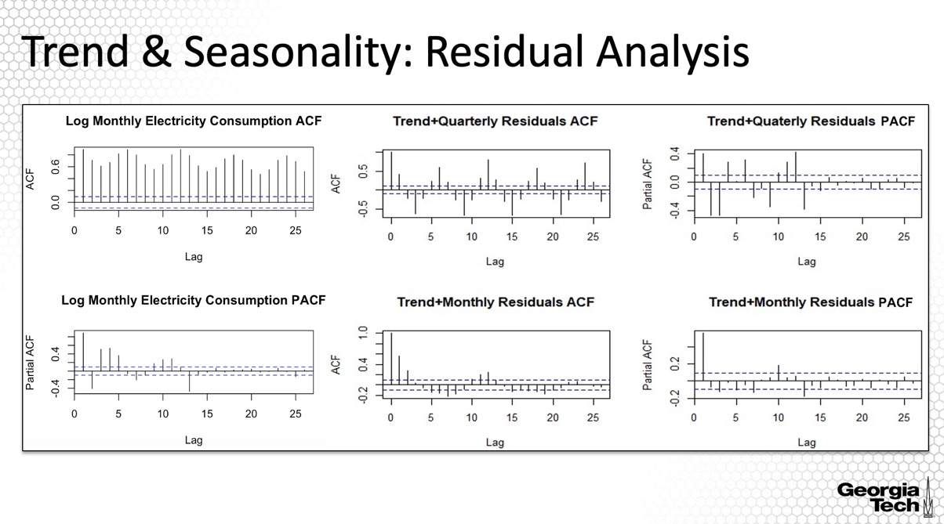

This slide presents the ACF and PACF plots for the original and log-transformed time series on the column on the left. On the right, I added the plots for the residuals of the two models. We can see that “trend+quarterly seasonality” residuals still contain seasonality in the acf and pacf pots. The acf plots for the “trend+monthly seasonality” residuals show that there is still some seasonality pattern although most of the sample auto-correlation and partial auto-correlation values are within the confidence bands or close to the confidence bands. It is possible that there are still some seasonality factors not captured by either monthly seasonality. This might due to temperature changes and environment behaviors that could impact people’s electricity consumptions in each year.

**Summary:**

This lesson provided the exploratory analysis of the the trend and seasonality for the time series of the electricity consumption in the US. When removing seasonality and trend, we could tell what is the effect of the trend, what is the effect of the seasons, and what is the effect that isn't accounted for by season nor trend through the residuals. We will continue on this line of analysis in the next lesson.

### 2.4.4 Energy Consumption: Forecasting

*This lesson continues the analysis of the time series of monthly electricity consumption. Here I will compare the predictions based on two forecasting approaches, one being the ARMA model applied to the residuals after fitting trend and monthly seasonality and the second being the seasonal ARIMA.*

**Energy Consumption**

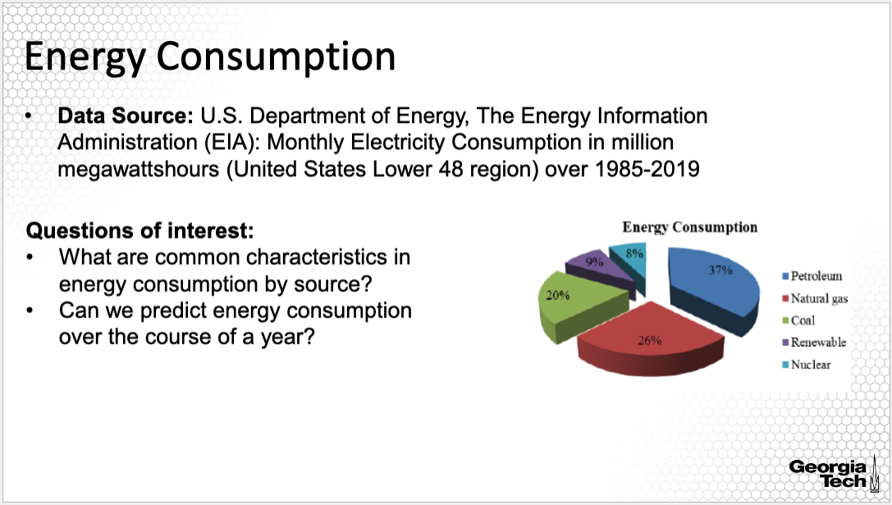

Our focus again is in forecasting electricity consumption as a proxy of energy consumption over the period of one year, analysis that could be useful in pricing, load allocation and management of generation and transmission infrastructures. For example, we have seen from the previous lesson that there has been an increasing no-linear trend in electricity consumption since 1985, indicating the need of potentially new infrastructures. We also have identified a monthly seasonality, which can be used in inferring load allocation.

**Assessing Stationarity**

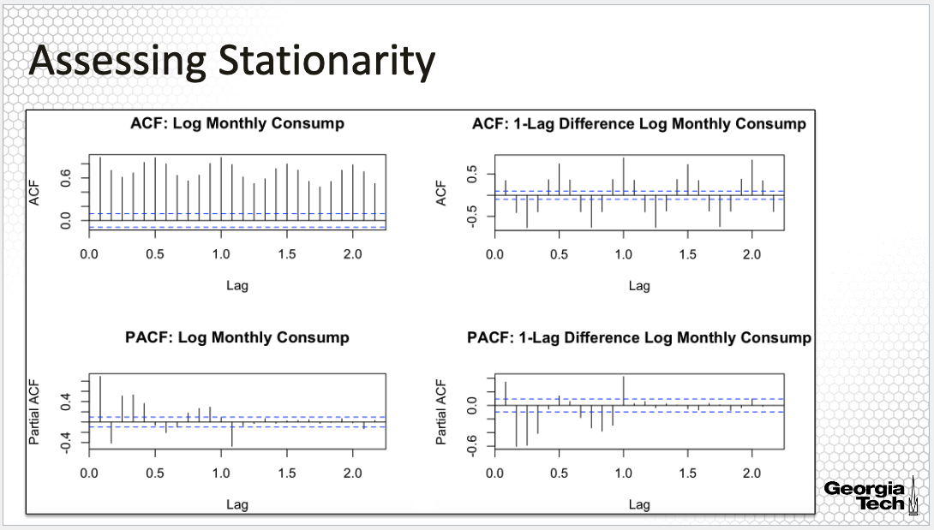

I am returning now to the analysis of the log-tranformed data, displaying here the ACF and PACF plots of the log transformed time series on the left and the 1 lag difference of the time series on the right. The slow decay in the ACF is a sign of non-stationarity; in fact, we did identify a trend and seasonality in the data hence this result is not surprising. But we can see that even with the first order differencing, we observe that there is a pattern in the ACF plots, with large values following a seasonal pattern. This thus suggests a seasonal difference would need to be applied.

**Assessing Stationarity: Trend & Seasonality**

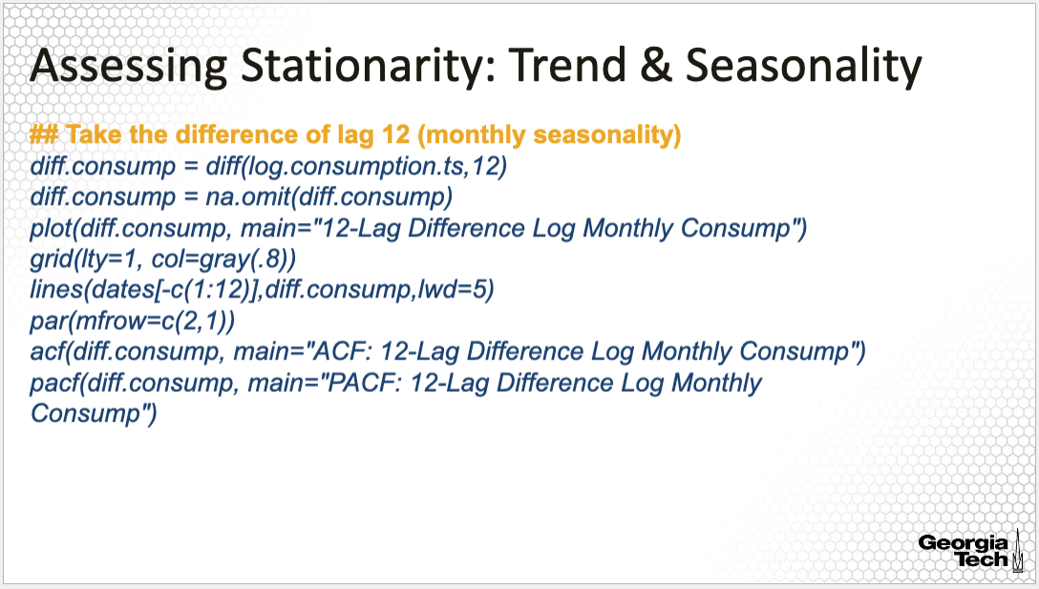

Next we are analyzing the 12-lag difference time series to account for seasonality. The R code for this differencing along with the corresponding plots is here.

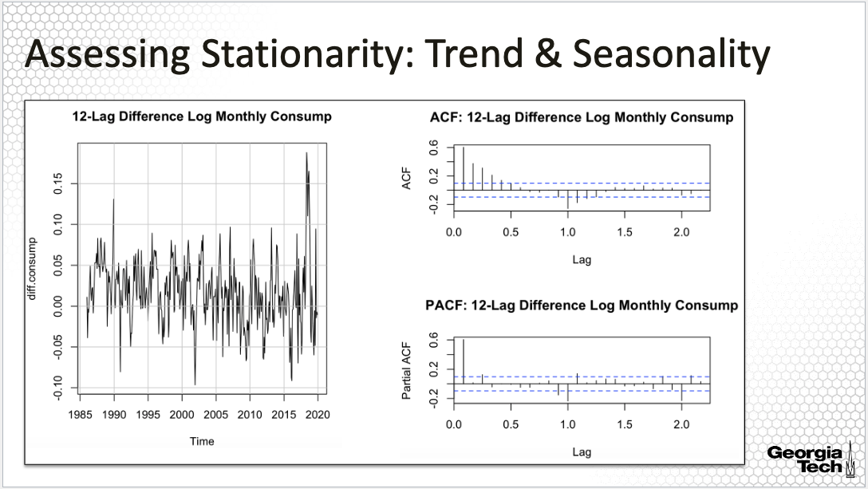

The seasonality seemed to have been removed with the differencing, with no distinguishable pattern in the time series as shown in the time series plot on the left. The ACF/PACF plots of the 12-lag difference of the log monthly electricity consumption are similar with the ACF/PACF plots of the residuals from the “spline+monthly seasonality” model. Thus, we can model further with the ARMA model either the difference process or the residuals from the “spline+monthly seasonality” model. Here we will use 12-lag difference of the log monthly electricity consumption for ARIMA modeling.

**Difference Time Series: ARMA Model**

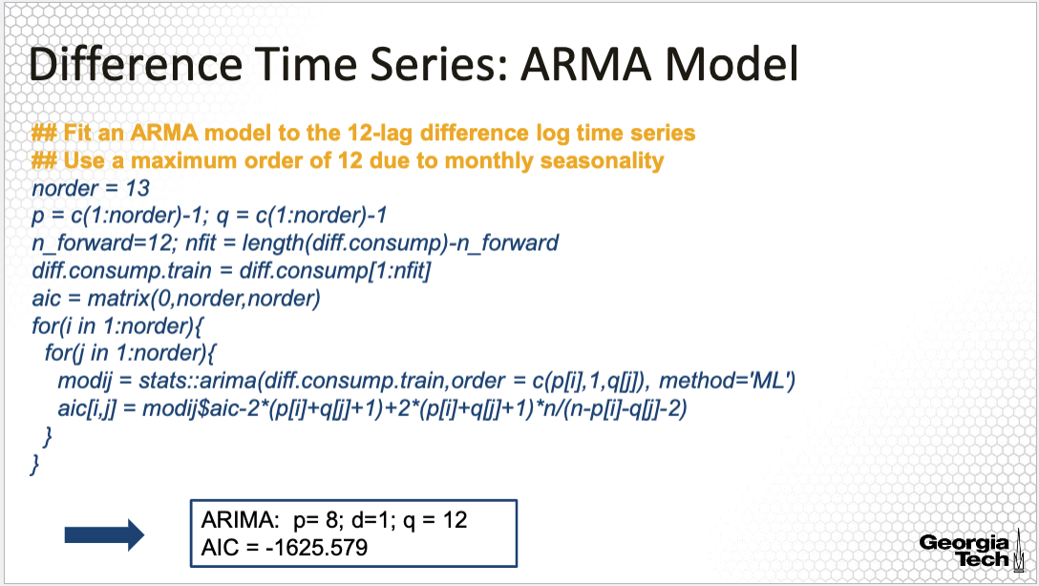

Now, we are ready to model the residual process of the log monthly electricity consumption with ARMA models. This is the code we used before for order selection applied this time to the 12-lag difference of the log-transformed data for the monthly electricity time series.

The selected orders are p= 8; q = 12 assuming we also apply a one order difference to account for any other potential trend in the data.

**Difference Time Series: ARMA Model (cont’d)**

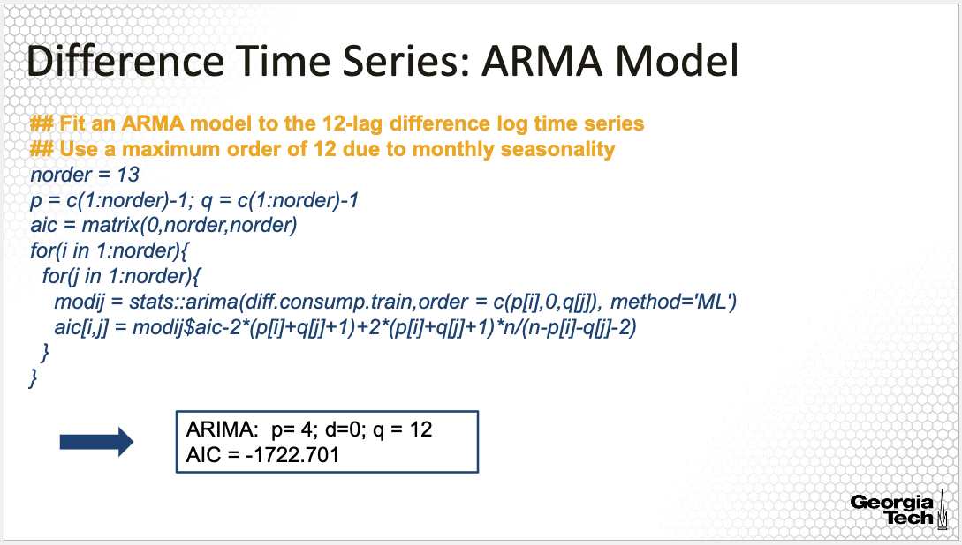

If instead we take d=0, that is, we don’t apply yet another difference, then the selected orders are p= 4; q = 12. A few observations are to be noted. I will also highlight that I divided the data into training and testing data, where the testing data consists of the monthly observations from 2019, that is, one year of data. I applied the arima modeling including model selection on the training data. The testing data will be used to evaluate the prediction accuracy. The model with d=1 does not perform better than the model with d=0 when comparing the AICC values. Moreover, the model with d=0 is less complex since the AR order is 4, lower than the model in the previous slide. For the rest of the analysis, I will use this model.

**ARMA Model: Residual Analysis**

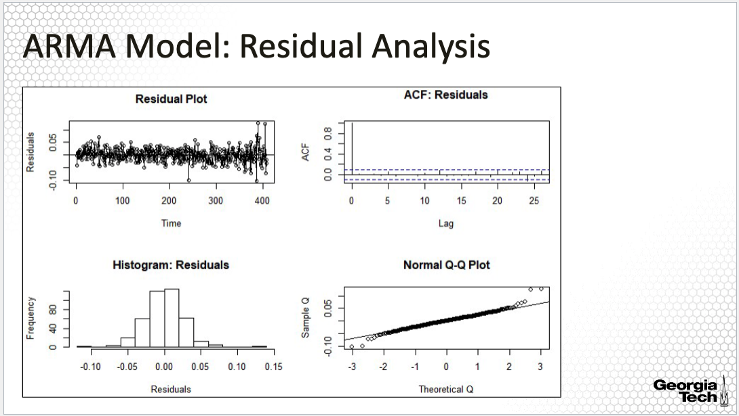

The residual plots for the model in the previous slide are here. The residuals seem to behave like a white noise with a normal distribution. The normality is assessed using the quantile-quantile normal plot and the histogram on the bottom.

**Time Series: SARIMA Model**

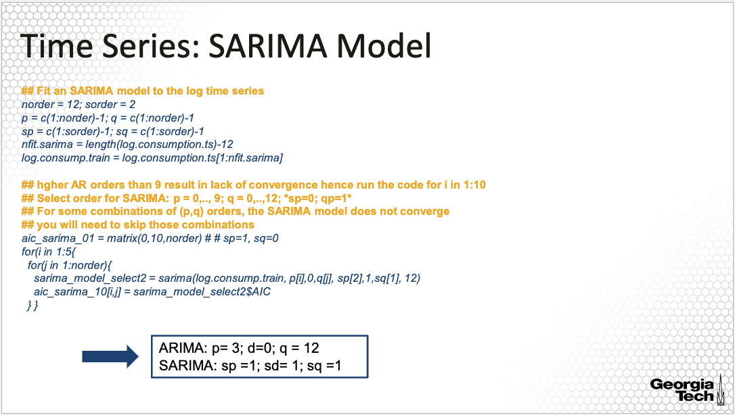  
Next I applied an SARIMA or seasonal ARIMA model to the log-transformed data. The selected model is an ARMA with orders p= 3; d=0; q = 12 and SARIMA with orders sp =1; sd= 1; sq = 1. Selecting the orders for the SARIMA is time consuming; for that, I considered only small orders for the seasonal component of the model. I also note here that the ‘sarima’ command here does not converges for all combinations of the ARMA orders. For example, the SARIMA does not converge for an AR order larger than 9 hence for I restricted here to a ‘porder’ taking values from 0 to 9. The code provided on the slide is for sp=1, sd=1 and sq=0. While here the code includes all combinations of p and q, as you will run the code, you will find that the code will stop for some combinations of (p,q). You will have to exclude these combinations then run the code again.

**SARIMA Model: Residual Analysis**

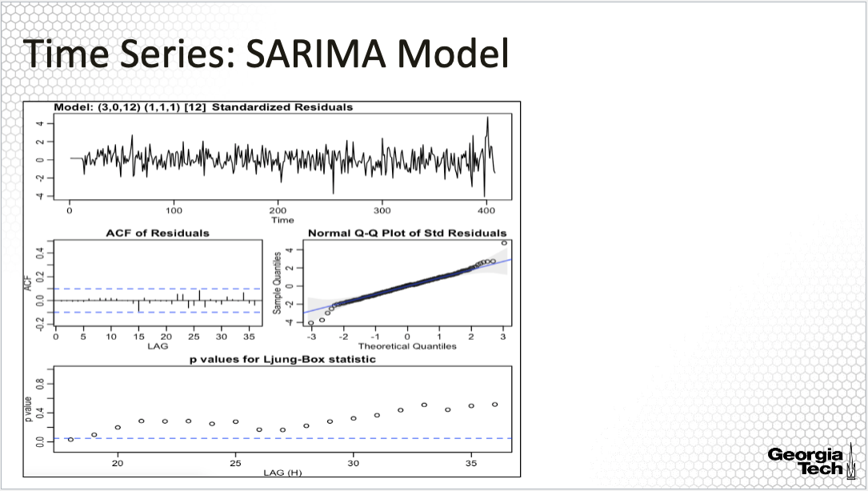

Here I am providing the residual analysis for the SARIMA model. Except for a slight increase in the variability in the residuals over time, the residuals seem to be white noise, normally distributed. On the bottom, I am providing the plot of the p-values for the Box-Ljung test for serial correlation for varying lag values. Note that we generally explore serial correlations for lags larger than the sum of the model orders. From this plot, we see that the p-values for all lags are larger than the threshold 0.05, suggesting once again that it is plausible that the residuals are white noise.

**ARMA &Differencing vs SARIMA Model**

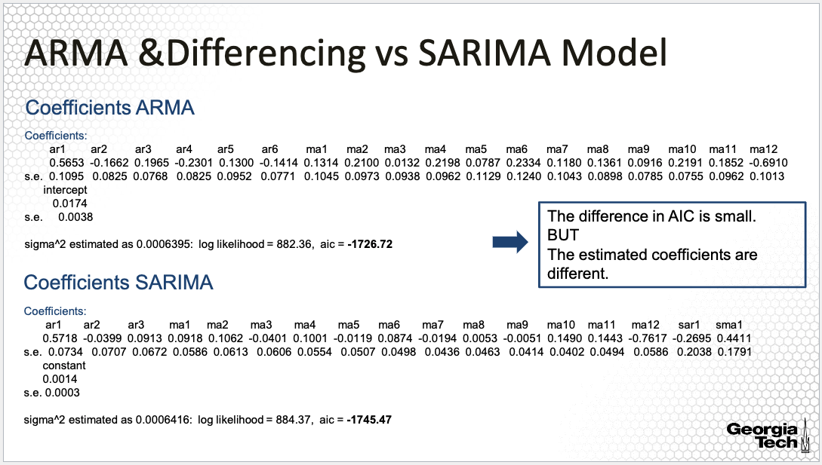

Here I am comparing the estimated coefficients for the two models, the ARIMA model for the differenced time series and the SARIMA model. First, I will point out that the estimated coefficients for the ARMA portion of the model are quite different; this is expected since these are two different models. However, I will also note that the AIC value is quite similar, suggesting that the two models perform rather similar with respect to this criterion.

**ARMA & Differencing: Forecasting**

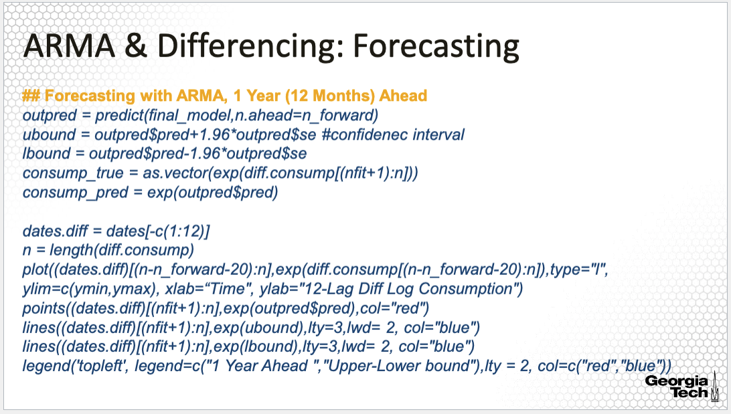

In the last part of this analysis, we will look at the forecasting accuracy of the two models. Here am providing the R code for deriving the forecast for the 12 months ahead along with the confidence bands. The code here is for comparing the observed time series for these 12 months to the predictions.

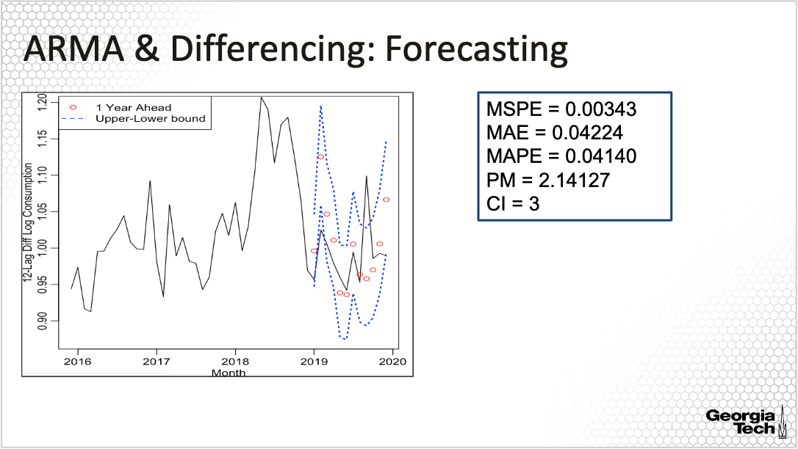

The plot is on the slide along with the accuracy measures for this prediction. The predictions follow the observed differenced data to some extent and all observations are within the prediction bands. The precision is 2.1, meaning that we have twice as much variability in the prediction as in the observed data, an indication of a rather poor prediction.

**SARIMA: Forecasting**

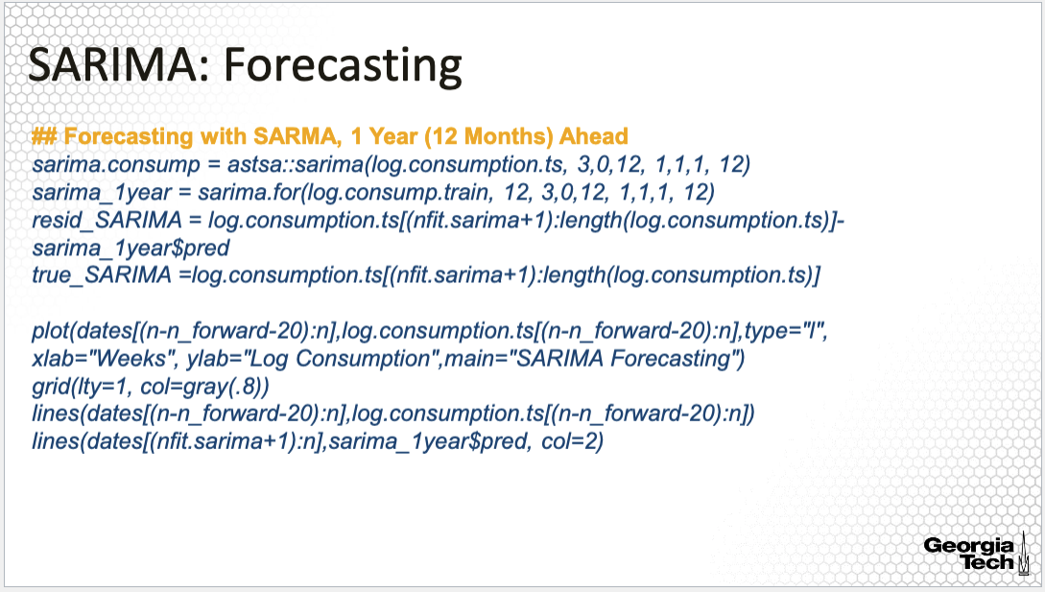

Next I am evaluating the prediction of the SARIMA model. Note that here I am not using the standard predict command to obtain the predictions but the sarima.for() command that makes predictions one or more periods at time. For example here, the prediction is one period, or one year ahead.

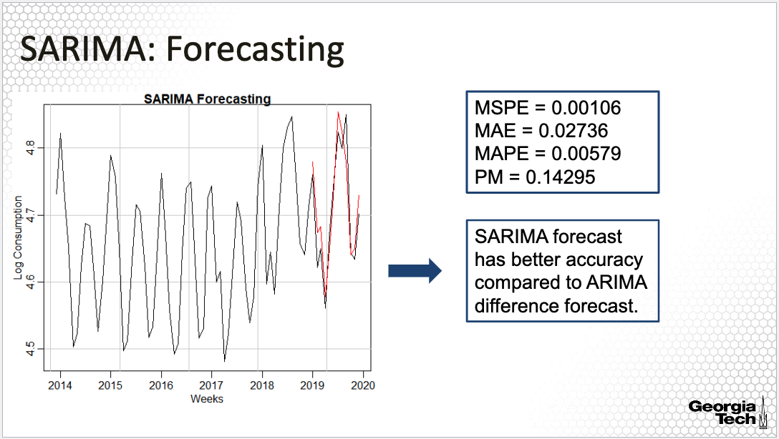

Here is the plot along with the accuracy measures. Both the plot and the accuracy measures show reasonably good predictions. The predictions follow the observed data to a great extent and the precision measure is 0.14, meaning that the prediction has only 14% of the variability in the data.

This tells us that the prediction based on the SARIMA model is much better than that for the ARIMA model applied to the difference data. As an example, the precision measure for the ARMA was 2.14. One reason for this could be because the seasonality is the dominant part of the time series and here a model that incorporates prediction of the seasonality as well as the stationary process after accounting for seasonality would perform much better. Thus, in forecasting, it is recommended to use a seasonal ARIMA model if the model has seasonality and trend.

**Forecasting Comparison**

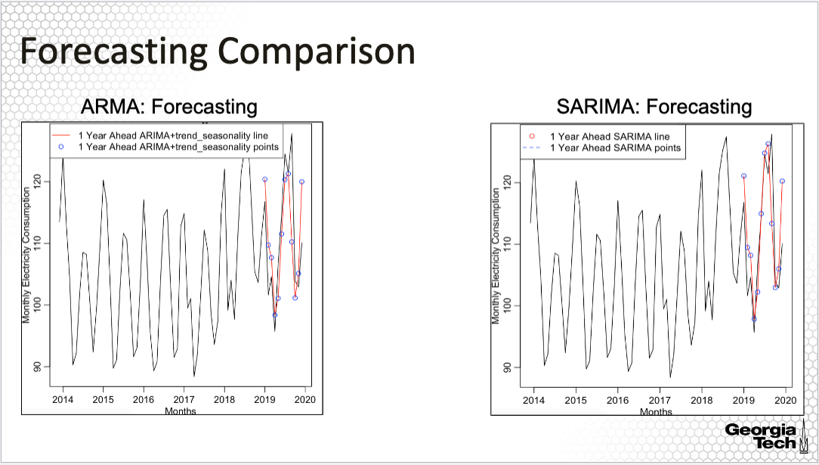

This is a more fair comparison of the forecasts since I am comparing the SARIMA forecasts along with the forecast of the time series based on an ARMA model applied to the residuals removing the trend and seasonality shown in the figure on the left; the prediction of this model accounts for the seasonality and trend also. We see now that the two forecasting approaches perform quite similarly with small differences.

This confirms the intuition that for this time series, accounting for seasonality in the prediction makes it for a better prediction! More generally, you will need to understand the importance of modeling the seasonality. Is seasonality of interest or is it just a nuisance? How you deal with seasonality depends on the answer to this question. As an example, if you are interested in describing the pattern of seasonality in the time series of monthly energy consumption, then seasonality is of interest and you will not want to discard it completely - rather, you will want to directly model it and use it in the forecasting model as provided in this example.

**Summary:**

This last lesson illustrating forecasting models for time series with seasonality concludes Module 2.